

**Self-Love Adventure**

**Workbook**

Contents

Welcome! 3

Getting Started 3

Participation Details 3

Course Overview 4

Course Structure 4

Tapping with the Volunteers 5

Super Duper Important Information 6

Tapping Instructions 7

Tapping Points Diagram 8

Description of Tapping Points 9

FAQs and Tips for Tapping Points 9

Negative Feelings List 10

Positive Feelings List 11

# Welcome!

Hi, and welcome to the Self-Love Adventure. Congratulations on making such a genuine commitment to the most important relationship in your life – the one with YOU. Most people acknowledge it is important, but they rarely take the time to focus on it, even though it improves every single area of your life! They usually spend most of their time making more money or acquiring things. So I want to recognize you for committing to doing this work and showing that you truly do value your relationship with yourself.

So congratulations and welcome!

## Getting Started

This beginning chapter will help you be ready for the first class. First and most important, please fill out the REALLY IMPORTANT ASSESSMENT (online – you should have received a link to it). Second, fill in the information in the Live Call Participation Details section just below so that you have it handy. Many people find themselves hunting wildly for the call in # when it’s time to call in, so this way you will have everything in one place. Third, read through the rest of this chapter so that you are clear on how the course is organized so that you can get the most out of your investment.

## Participation Details

I recommend you write in the information below so that you have it handy when it is time to call in.

* We will have 6 live calls.
* The dates of the calls for this course are:
* These are on ______________ (day of week) at ________________ (time). The call in # will be _____________________ and participant code is _____________________.
* All calls will be recorded and a link emailed to you so you can download them.

## Course Overview

* On the welcome page you will see links to:
  + **Workbook** - I recommend printing it, although you can also type directly into the document using Word if that is easier.
  + **Tapping Insructions/ Video** – this explains a bit more about what tapping is and a demonstration of how to do it.
* Please review the Tapping page if you are new to Tapping. It will give you some practice trying it out and help you be up to speed when we start in with the first step.
* At the end of this Welcome Chapter are the following reference materials:
  + **Tapping Instructions** – instructions to refer to after you have watched the video
  + **Diagram of Tapping Points** - you can keep on hand just to make sure you remember them. After a week or two, I’m sure you won’t need it.
  + **Negative & Positive Emotions List** - Many times in the course I’m going ask you to identify how you feel, and sometimes it is hard to put labels on feelings, to describe them, so these lists can be useful to refer to in order get some ideas of the different emotions there are and help you name them.

## Course Structure

* Each week we will have a live call. There will be several pages you will use in the workbook for each step.
  + **Notes Page** - a good place to keep any freehand notes while listening
  + **Instructions** – step-by-step instructions on how to organize your tapping for that week, how to know what issues you need to address for that week.
  + **Tables and Worksheets** - these will help you set yourself up for tapping for that particular week and include a phrase generator, so you know exactly what to say.
* You will want to listen to the recording and fill out the tables in the worksheet prior to the live class.

## Tapping with the Volunteers

* The second part of our class each week will be question and answer about the material and live tapping. Anybody in our group who is interested to volunteer to be on the “hot seat” can do so and I will lead you through tapping on your particular issue on the live call. Just email me at [aimee@aimeeserafini.com](mailto:aimee@aimeeserafini.com) if you’d like to volunteer in advance for a particular week. I encourage everyone to volunteer if you can join the class live, and I will try to get in as many as I can. You will get some direct coaching and some further ideas of where to go with your issue. If you are shy or don’t want to volunteer, I still recommend that you listen to call the live and tap along with us.
* When I am leading someone through tapping on their issue, whether you are listening to a recording or joining us live, you will see the best results if you join in with us.
* When you are tapping along with us, here are a few points to keep in mind. If the issue that the volunteer has is not the same as yours, that’s okay. It will still help you.
  + Before we begin the tapping, briefly focus on an issue YOU have.
  + Write down your issue.
  + Write down your rating on a scale of 0-10 as to how much it is bothering you (if you have questions on what this means, review the How to Tap Video.
  + Then follow along with us, repeating the words after me, just as the volunteer is doing, even if it has nothing to do with your issue (you can change the words if you want, but you don’t need to).
  + When we complete a round of tapping and I’m asking the volunteer for her new rating number, briefly reassess your own number for your issue. Strangely, you will almost always find that your intensity reduced as well. It’s a weird phenomenon called Borrowing Benefits that’s been documented for your years.
  + If after reassessing your number, you find your intensity has gone down to a zero on your issue, then pick another issue to work on, and again write it down and your new number and continue tapping with us.
  + If your original issue hasn’t cleared to a zero, then briefly refocus on your same issue, re-rate it and continue tapping with the live caller.

## Super Duper Important Information

* The most important thing you can do prior to the course is fill out the QUESTIONNAIRE online. The reason is because it is sooooo easy once we clear something to forget that it was ever a big deal to us, which is really a good thing in general, but for this process we need to have some notes to refer back to because you will not remember them once you let go. They will remind you of areas you may have forgotten to address, and are also a great test for whether you truly cleared something or more tapping is needed. So please fill out that questionnaire. At the end of the course I’m also going to provide you some questions to answer, and that questionnaire will help then too.
* In between calls, it is really important that you continue to tap EVERY DAY on the issues and ideas that were covered in that week's lesson. You will be given a clear idea at the end of each step of how to continue tapping each week. Even if it’s only for five minutes, this needs to be a priority. Ideally it would be 10 minutes twice a day, or 20 minutes, even more, depending on how much comes up for during any one lesson. I really recommend early in the morning and late at night, although if you have a time when you are alone, like in the car or walking the dog, that would also be a good time. But our evidence shows that people who do their tapping on their own get the best results.
* We have 5 steps in the process, and you may find one particular lesson really brings up a lot for you more than another, and I recommend continuing to tap as long as you need to after the course. But during the course, try to use each week to tap on that week’s material. I ask that so that you can ask questions and get feedback and really understand each step at the time we are covering it. You can always go back to any step after the course is over.
* And lastly, I have created a secret Facebook group page for our group. It’s a good place to post questions, get support, share aha moments. I will check in with regularly and answer as many questions as I can. So if you friend Aimee Serafini

# Tapping Instructions

This is a brief recipe for how to tap. Please refer to the diagram on the next page for the location of the specific tapping points. Also, watching the How to Tap video will help it all come together.

1. **Target** - Define the issue you want to work on. Ideally this will involve an emotion and a reason. An example would be “I feel angry when Steve ignores me.” You are noting an emotion – anger - and the reason – Steve ignores me.
2. **Rate It** – feel that emotion that you have, in this case anger, and rate it on a scale of 0 – 10 where zero means you don’t feel it at all and 10 means it couldn’t be any stronger. A lot of people get hung up on getting their “number right”. Don’t worry about it too much, just go with the first number that pops in your head. If you pick a 10, it doesn’t mean you’ve never been angrier in your life, or that you have a right to have the most anger of anybody in the world, just that it is so strong right now that you can’t imagine it could get worse (even if it actually could).
3. **Set-up Phrase** – it follows this pattern: Even though I feel (emotion)_ when (reason)_, I completely love and accept myself. So in our example it would be Even though I feel angry when Steve ignores me, I completely love and accept myself.   
   **Tapping on Karate Chop** – repeat your setup phrase 3x while tapping on the Karate Chop point (see diagram below). I recommend saying the words out loud whenever possible.
4. **Tapping Through the Points** – You will tap at least 3 times on each of the 8 points identified in the diagram below while repeating the name of your emotion. So in our example it would be saying “this anger”.   
   I like to start with the eyebrow, then side of eye, under eye, under nose, chin, collarbone, under arm, and top of head. In our example, I’d start tapping on the eyebrow point and say “this anger”, then tap on the side of the eye and say “this anger”, etc. I have numbered the points in the diagram below so you can see the sequence. If you skip one, don’t worry about it.
5. **Deep breath** – after you have tapped through all the points at least once repeating your emotion (I usually tap through 3 or 4 rounds at a time), take a deep breath.
6. **Re-rate your intensity** - Repeat your target sentence out loud (I feel angry when Steve ignores me) and tune into how you feel now in order to re-rate your number. Has it stayed the same, gone up, or gone down? Write down your new number.
7. **Repeat steps 3-7** until the intensity has gone down to a 0 or 1. You can tweak your setup statement to say “Even though I still feel angry that Steve ignores me” if you want.

# Tapping Points Diagram

**Karate Chop Point for Setup Phrase**

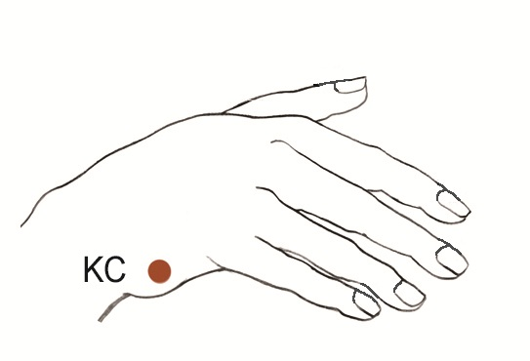

**Tapping Through the Points:** Start with Eyebrow (EB). See following page for descriptions of each point.

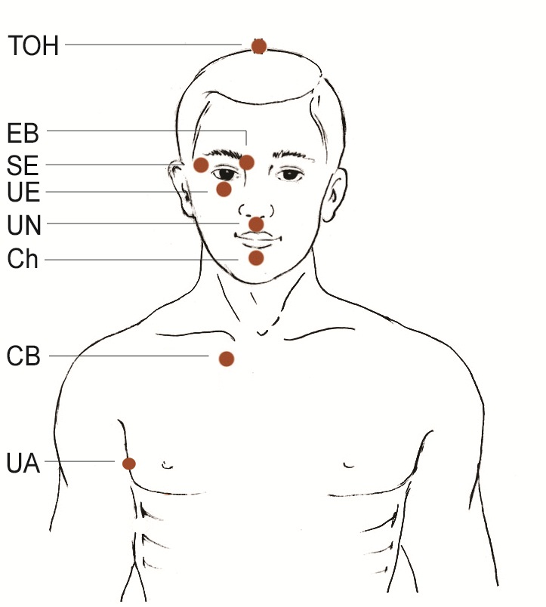

## ****Description of Tapping Points****

**KC:** The Karate Chop point is the outside side of your hand (either hand) between the wrist and the base of the pinky, or the part of your hand you would use to deliver a karate chop. Abbreviated KC

**TOH:** On the top of the head, or the crown of your head, midway between forehead and the back. Abbreviated TOH.

**EB:** At the beginning of the eyebrow, where the hair starts nearest the nose. You’ll be tapping on both skin and hair when on this point. Abbreviated EB.

**SE:** On the round bone bordering the outside corner of the eye.  Abbreviated SE for Side of the Eye.

**UE:** On the bone under an eye about 1 inch below your pupil.  Abbreviated UE for Under the Eye.

**UN:**  Between the bottom of your nose and the top of your upper lip.  Abbreviated UN for Under Nose.

**Ch:** Midway between the point of your chin and the bottom of your lower lip, in the crease.  Even though it is not directly on the point of the chin, we call it the chin point because it is descriptive enough for people to understand easily.  Abbreviated Ch for Chin.

**CB:** The junction where the sternum (breastbone), collarbone, and the first rib meet.  To locate it, first place your forefinger on the U-shaped notch at the top of the breastbone (about where a man would knot his tie).  From the bottom of the U, move your forefinger down 1 inch and then go to the left (or right) 1 inch.  Abbreviated CB for CollarBone even though it is not exactly on the collarbone.

**UA:** On the side of the body, at a point even with the nipple (for men) or in the middle of the bra strap (for women).  It is about 4 inches below the armpit.  Abbreviated UA for Under the Arm.

## ****FAQs and Tips for Tapping Points****

* You can tap on either side of your body (for example side of left eye or side of right eye), both sides are equally good. You can also switch it around whenever you want - in the middle of rounds or between rounds, or stay on the same side all the time. It is up to you. If you want to tap with both hands on both sides at the same time, that’s fine too.
* You can also switch hands when you tap these points. Tapping with left hand or right hand is equally effective.
* The tapping is done with two or more fingertips. This is so you can cover a larger area and thereby insure that your tapping covers the correct point.
* While you can tap with the fingertips of either hand, most people use their dominant hand. For example, right handed people tap with the fingertips of their right hand while left handed people tap with the fingertips of their left hand.
* You tap approximately 5 times on each point. No need to count the taps because anywhere between 3 and 7 taps on each point is adequate. The only exception is that you will continually tap on the Karate Chop Point while you repeat the set-up phrase.

# Negative Feelings List

|  |  |  |  |
| --- | --- | --- | --- |
| AFRAID apprehensive dread foreboding frightened mistrustful panicked petrified scared suspicious terrified wary worried  ANNOYED aggravated dismayed disgruntled displeased exasperated frustrated impatient irritated irked  **ANGRY** enraged furious incensed indignant irate livid outraged resentful  AVERSION animosity appalled contempt disgusted dislike hate horrified hostile repulsed | CONFUSED ambivalent baffled bewildered dazed hesitant lost mystified perplexed puzzled torn  DISCONNECTED alienated aloof apathetic bored cold detached distant distracted indifferent numb removed uninterested withdrawn  DISQUIET agitated alarmed discombobulated disconcerted disturbed perturbed rattled restless shocked startled surprised troubled turbulent turmoil uncomfortable uneasy unnerved unsettled upset | EMBARRASSED ashamed chagrined flustered guilty mortified self-conscious  FATIGUE beat burnt out depleted exhausted lethargic listless sleepy tired weary worn out  PAIN agony anguished bereaved devastated grief heartbroken hurt lonely miserable regretful remorseful  SAD depressed dejected despair despondent disappointed discouraged disheartened forlorn gloomy heavy hearted hopeless melancholy unhappy wretched | TENSE anxious cranky distressed distraught edgy fidgety frazzled irritable jittery nervous overwhelmed restless stressed out  VULNERABLE fragile guarded helpless insecure leery reserved sensitive shaky  YEARNING envious jealous longing nostalgic pining wistful |

# Positive Feelings List

|  |  |  |  |
| --- | --- | --- | --- |
| AFFECTIONATE compassionate friendly loving open hearted sympathetic tender warm  ENGAGED absorbed alert curious engrossed enchanted entranced fascinated interested intrigued involved spellbound stimulated  HOPEFUL expectant encouraged optimistic | CONFIDENT empowered open proud safe secure  EXCITED amazed animated ardent aroused astonished dazzled eager energetic enthusiastic giddy invigorated lively passionate surprised vibrant | GRATEFUL appreciative moved thankful touched  INSPIRED amazed awed wonder  JOYFUL amused delighted glad happy jubilant pleased tickled  EXHILARATED blissful ecstatic elated enthralled exuberant radiant rapturous thrilled | PEACEFUL calm clear headed comfortable centered content equanimous fulfilled mellow quiet relaxed relieved satisfied serene still tranquil trusting  REFRESHED enlivened rejuvenated renewed rested restored revived |

© 2005 by Center for Nonviolent Communication  
Website: [**www.cnvc.org**](http://www.cnvc.org/) Email: [**cnvc@cnvc.org**](mailto:cnvc@cnvc.org)  
Phone: +1.505.244.4041